**Install Webstrom**

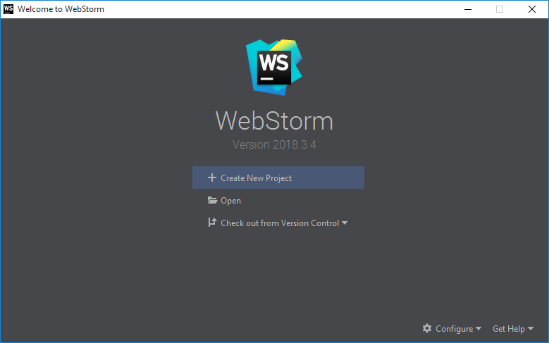

**Install Node.js**

You can download from https://nodejs.org/en/download/

**Run Command prompt as administrator**

You can check node.js is installed or not by executing the command

* node –version



**Go to Project location**

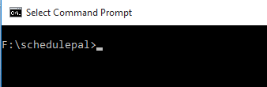

**Execute all the given command**

* npm install --global --production windows-build-tools
* npm rebuild
* npm install mysql
* npm start

**E.g.**

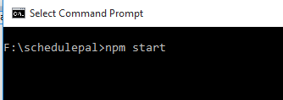

**Enter**

**You can access**

http://localhost:8081/

**Install MYSQL**

<https://dev.mysql.com/>

**Create the database**

Change the database name and other database information in **Server/datasource.json**

